H.T No
Regulations:
A18

Sreenidhi Institute of Science and Technology
(An Autonomous Institution)
Code No: 7A304 Date: 22-Jan-2025 (FN)

B.Tech II-Year I- Semester External Examination, Jan/Feb-2025 (Supplementary)
ELECTRICAL CIRCUITS AND NETWORKS – II (EEE)

Time: 3 Hours Max.Marks:70

Note: a) No additional answer sheets will be provided.
b) All sub-parts of a question must be answered at one place only, otherwise it will not be valued.
c) Missing data can be assumed suitably.
Bloom's Cognitive Levels of Learning (BCLL)

Remember | L1 | Apply | L3 | Evaluate | L5
Understand | L2 | Analyze | L4 | Create | L6

Part - A Max.Marks:20

Answer all QUESTIONS.

 |  | BCLL | CO(s) | Marks
1 | Write the relationships between line and phase currents for a star and delta connected system. | L1 | CO1 | [2M]
2 | A circuit consists of a resistor connected in series with a 24mH inductor and has a time constant of 12 milli-sec. Determine the value of the resistor. | L2 | CO2 | [2M]
3 | What are the functions defined for one port network? | L1 | CO3 | [2M]
4 | Name the 6 different two-port parameters for a given two-port network. | L1 | CO4 | [2M]
5 | Define low pass and high pass filters. | L1 | CO5 | [2M]
6 | Write the conditions for existence of Fourier transform | L2 | CO6 | [2M]
7 | State the two ways in which phases of a three phase supply can be interconnected to reduce the number of conductors used compared with three single-phase systems | L3 | CO1 | [2M]
8 | Write the necessary conditions for (a) Driving point function (b) Transfer function. | L3 | CO3 | [2M]
9 | Define band pass filter and band elimination filter. | L1 | CO5 | [2M]
10 | Define the term half wave symmetry and quarter wave symmetry | L1 | CO6 | [2M]

Part – B Max.Marks:50
ANSWER ANY FIVE QUESTIONS. EACH QUESTION CARRIES 10 MARKS.

 |  |  | BCLL | CO(s) | Marks
11. | a) | Explain the method of measuring reactive power in a 3-phase balanced system using a  Single watt meter method. | L3 | CO1 | [5M]
 | b) | A four-wire star-star circuit has Van = 120∠120⁰, Vbn = 120 ∠0⁰ Vcn = 120 ∠− 120⁰ V.  If the impedances are Zan = 20∠60⁰, Zbn= 30∠0⁰ and Zcn = 40∠30⁰, find the current in the neutral line. | L3 | CO1 | [5M]
12. | a) | In a series RLC circuit L=0.5 H, and C=2 F. A DC voltage of 20 V is applied at t=0. Obtain  an expression for current i (t) in the circuit, when (i) R= 3Ω (ii) R= 4Ω | L4 | CO2 | [5M]
 | b) | Derive an expression for voltage across ‘R’ in a series R-C circuit excited by a unit step Voltage. Assume zero initial conditions. | L3 | CO2 | [5M]
13. | a) | 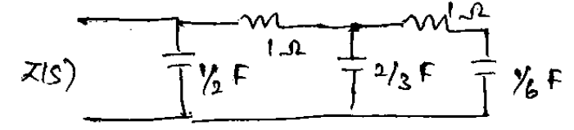  For the network shown, find z(s) and pole zero diagrams | L3 | CO3 | [5M]
 | b) | For the ladder network shown in figure find the driving point – impedance at the 1-1’ terminal with 2-2’ open  . 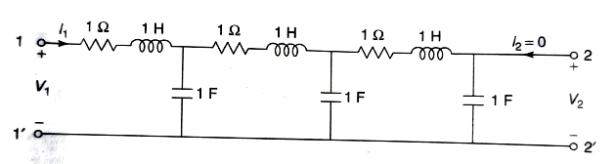 | L3 | CO3 | [5M]
14. | a) | Determine h-parameters of a two-port network whose z parameters are Z11= Z22=6 ohms and Z12=Z21=4 ohms. | L4 | CO4 | [5M]
 | b) | Find the transmission parameters of the network shown Figure. 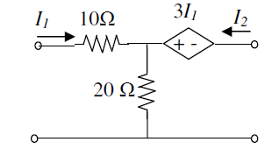 | L4 | CO4 | [5M]
15. | a) | Find the characteristic impedance, cut- off frequency for the network shown in figure. 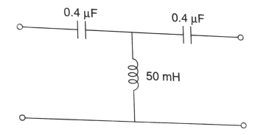 | L3 | CO5 | [5M]
 | b) | Design a T- section constant –K high- pass filter having a cut – off frequency of 10 kHz and a design impedance of 600 Ω. Find its characteristic impedance and phase constant at 25 kHz. | L6 | CO5 | [5M]
16. | a) | Find the Exponential Fourier series for the wave form shown Figure. 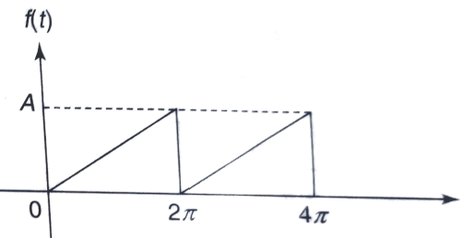 | L5 | CO6 | [5M]
 | b) | List the properties and applications of Fourier transform. | L3 | CO6 | [5M]
17. | a) | For the circuit shown in figure 3, the line voltage is 240 V. Take Vab as reference and determine following: i) phase currents, ii) line currents  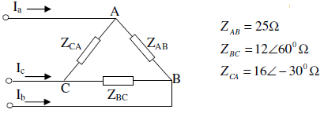 | L4 | CO1 | [4M]
 | b) | An un-charged 80 μF capacitor is connected in series with a 1 kΩ resistor and is switched  across a 110V supply. Determine the time constant of the circuit and the initial value of  current flowing. | L4 | CO2 | [3M]
 | c) | What is network function? Define the terms “Driving point impedance” and “driving point admittance” of a one port network. | L3 | CO3 | [3M]
18. | a) | Explain the cascade connection of two port networks. Which type of 2-port parameters is ideal for such a cascade connection? | L3 | CO4 | [4M]
 | b) | What is a filter? Explain about various types of filters. | L3 | CO5 | [3M]
 | c) | List out the conditions for existence of Fourier transform | L5 | CO6 | [3M]
-- 00 -- 00 –

